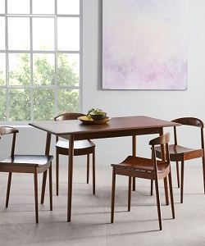

Latest Dining table

$16.33

Availability: In stock

Description

This furniture features a curved back and seat for comfortable seating and the modern stool design will add a splash of style to your dining area. Cute small brown chairs with height dining table, mid-century dining table